|  |
| --- |
|  |
| Finding Dawn |
| If you move, you survive |
| Version 0.6  All work Copyright © 2018 by Silly Arts Games.  All rights reserved. |
| **Harshil Mehta**  **Pragnesh Patel**  **Dylan Schmidt-Cunningham** |
|  |

|  |
| --- |
| April 22nd 2018 |

**Table Of Contents**

**Version History** 2

Game Overview 3

Game Play Mechanics 3

Camera 4

Controls 5

Game Interface 5

**M**enuand Screen Descriptions 10

**G**ameWorld 10

Levels 11

Characters 11

**E**nemie**s** 12

**I**tems 13

# Version History

Github Repository : <https://github.com/harshilme2/Game-Project>

**Version 0.6**: Apr 22, 2018

Code Freeze and Post-Mortem

Total Commits – 47

Description: Fixed the movement bug when pressing Spacebar. Health system is working good now and takes effect. There are collectables added to game like life, powerups( only one right now to boost the movement speed ).

Hosted: <https://harshilme2.itch.io/findingdawn>

Blog: <https://findingdawn.weebly.com/post-mortem.html>

**Version 0.5**: Apr 15, 2018

Beta Release

Total Commits – 33

**Version 0.4**: April 2, 2018

Alpha Release

Total Commits – 6

**Version 0.3**: March 11, 2018

First Playable Build

Total Commits - 5

**Version 0.2**: Feb 16, 2018

Game Design Document

Total Commits - 1

**Version 0.1**: Feb 2, 2018

Project Setup - [Game Pitch & Game Design Document](https://e.centennialcollege.ca/d2l/lms/dropbox/user/folder_submit_files.d2l?db=177263&grpid=344305&isprv=0&bp=0&ou=344177)

Total Commits - 1

# Game Overview

It been long time since player has seen the day light. Fear of outside war kept the player trapped for long time. The place has become hard to survive and it’s time for player to move out for his survival. The goal of this game is to find your way out of dungeon*.*

# Game Play Mechanics

* Use weapon to kill the opponent
* Kill enemies by attacking with knife player already has with him
* Find your way out through dungeon
* Collect health on your way out
* Kill Enemy to gain points

# Camera

*This game has Top-Down camera view.*

*There are two Camera views*

1. *Main camera following Player. 16:9 ratio*
2. *Mini Map camera that covers entire map*

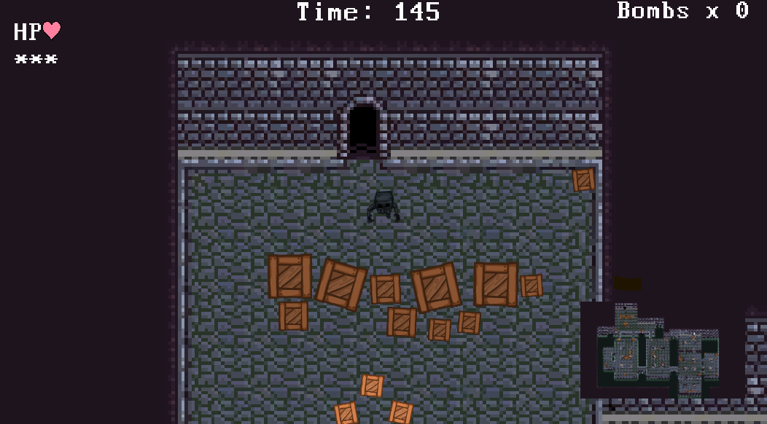

**Main Camera**

**Mini Map Camera**

# Controls

*This game will use arrow keys and Space bar. Alternatively, will use ASDW keys for movements.*

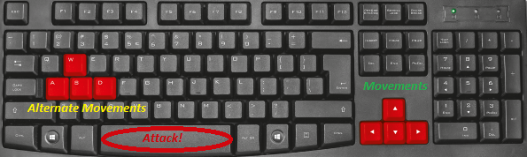

# Game Interface

Main Screen: 

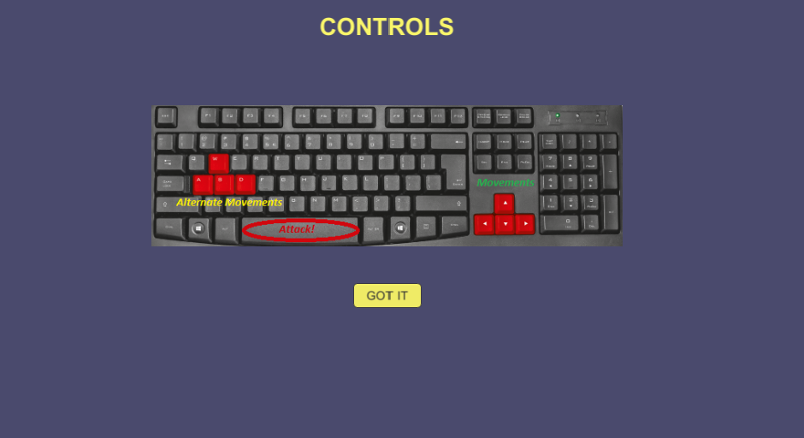

Map 1:

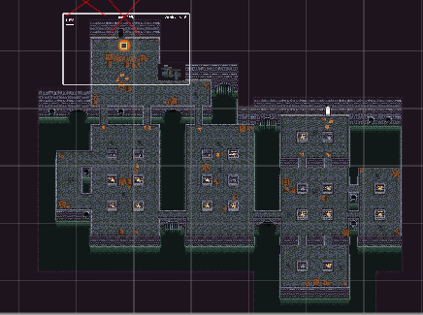

Map 2: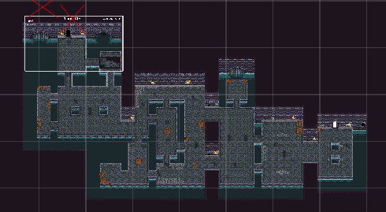

Map 3:

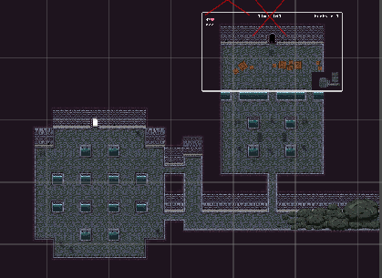

End:



Game Over:



# **M**enuand Screen Descriptions

*There will be timer and health given for player. Player enters from one end and exits on other end finding his way out. There will be time shown in on center top of screen and health in red as shown in below fig.*



# **G**ameWorld

It’s an underground old tunnel which was used for mining. It was abandoned for long time. My.Ribs was aware of it so went there to hide from outside war. Unfortunately, due to big explosion the main entry point of tunnel was blocked and there was no way out. Mr.Ribs has supplies and decided to stay inside till war gets over, but he cannot survive inside for long so now its time for him to find the way out. The tunnel somehow had flowing water which gave him hint that if water can come inside, then he can take it as clue to go out.

# Levels

*There will be three levels.*

*Level 1: Supply room –* Where he used to live and had stock up all his belongings. He had weapons too here which he needs to remember to collect. There are some areas where he has not been and one of the necessity will be to pass through it. This room is with supply boxes and wall. There are health powerup on this level shown by heart 

*Level 2: Scary room –* This is the room where he had never been, but he knew it existed. It has dangerous Spider. There will be a weapon and energy boost hidden on this level. This room has spikes.

There are health  as well as movement speed powerups and Timer

*Level 3: Outside room –* This room gives him hope as he sees first daylight from end of the room. But wait! There are giant bats that resides there. This map is relevantly small and once Mr.Ribs reaches here, he comes one step close to survival.

There are health  as well as movement speed powerups and Timer

# Characters

*Characters will be a human skeleton. His name is Mr.Ribs! He has been stuck for long, he looks like skeleton.*

# **E**nemie**s**

*Giant Beetle:*

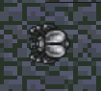

**Health**: high **Damage**: medium **Speed:** slow

Its slow speed leaves it vulnerable to ranged attacks. Just dodge them and find safe passage!

*Giant Spider:*

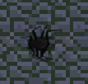

**Health**: medium **Damage**: medium **Speed:** medium

The biggest immediate threat of the three enemy types, these enemies should be a player's top priority...

*Poison spider:*



**Health**: low **Damage**: high **Speed:** medium

The biggest immediate threat of the three enemy types, these enemies should be a player's top priority...

*Bat:*

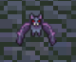

**Health**: low **Damage**: low **Speed:** fast

Generally just a nuisance, it's most dangerous in narrow halls with nowhere to go to dodge, when in a group, or when paired with tougher enemies that keep the player distracted

# **I**tems

*Spikes, Collectables like heart for health, Energy for timer.*

 Life

 SpeedUp

 TimeBoost